|  |  |  |
| --- | --- | --- |
| Thruput logo red on white | | |
| **Thruput Limited,** 6 Whitworth Road, Marston Trading Estate, Frome, Somerset, BA11 4BY, United Kingdom | | |
| E: support@thruput.co.uk | T: +44 1373 300 818 | W: www.Thruput.co.uk |

**Sentinel**

**Technical Supervisor**

**User Manual**

This document is the copyright of the Thruput Limited. No material may be reproduced, copied, translated or modified without the express written permission of Thruput Limited.

Sentineltm, MIDAStm, *The Graphix Factory*tm and TruePixeltm are trademarks of Thruput Limited

Thruput products are fully dvi_logo and **VESA** Compliant.

**Contents**

[1 Setting up 3](#_Toc528140852)

[1.1 Hardware 3](#_Toc528140853)

[1.2 Installation 3](#_Toc528140854)

[1.2.1 Desktop icons 3](#_Toc528140855)

[1.2.2 Time service 3](#_Toc528140856)

[1.3 Sentinel software licenses 3](#_Toc528140857)

[1.3.1 Positions without a physical software license key 3](#_Toc528140858)

[1.3.2 Positions with a physical software license key 3](#_Toc528140859)

[1.4 Generic software licenses 3](#_Toc528140860)

[2 Safety notes and instructions 4](#_Toc528140861)

[2.1 Virus protection 4](#_Toc528140862)

[2.2 After using Audio Monitor 4](#_Toc528140863)

[2.3 After using Live view 4](#_Toc528140864)

[2.4 After RMV and IDX decoding 4](#_Toc528140865)

[2.5 After remote controlling any station 4](#_Toc528140866)

[2.6 Scheduled maintenance 4](#_Toc528140867)

[3 User Interface 5](#_Toc528140868)

[3.1 Starting Technical Supervisor 5](#_Toc528140869)

[3.2 Active stations list 5](#_Toc528140870)

[3.3 Changing the default node colours 5](#_Toc528140871)

[3.4 Mimic display 6](#_Toc528140872)

[3.4.1 Acknowledge messages 7](#_Toc528140873)

[3.5 List of messages 8](#_Toc528140874)

[3.5.1 Information messages 8](#_Toc528140875)

[3.5.2 Warning messages 12](#_Toc528140876)

[3.5.3 Error messages 13](#_Toc528140877)

[3.6 Taking control of a station 16](#_Toc528140878)

[3.6.1 To close a remote viewing window 16](#_Toc528140879)

[3.6.2 Maintenance mode 16](#_Toc528140880)

# Setting up

The Technical Supervisor Position has two roles in the Sentinel installation:

1. Provides a real-time overview of the entire System status.
2. Provides engineering with diagnostics and support tools.

## Hardware

The Technical Supervisor comprises a Windows application, running on a PC or server with 1000baseT network links to all installed NAS recorders in the Sentinel system.

## Installation

After loading the installation disc, double click **Sentinel** Technical Supervisor and follow the on screen instructions to install.

The Technical Supervisor is a private service that provides a graphical interface to polled data from all stations and hardware components that are held in the log files of the NAS recorders. The technical supervisor enables the user to drill down into this data as required.

### Desktop icons

As part of the installation, an icon for the Technical Supervisor are automatically generated.



1. Desktop icons.

### Time service

The TSP, and all other servers on the Sentinel network require an NTP time service to ensure correct synchronization between data types and channels.

## Sentinel software licenses

The sentinel system is provided with site-specific software licensing using the *Wibu Systems CodeMeter.* The software licensing is intended to regulate the presence of un-authorised software applications on the network, without impacting on the correct recording and replay operations the delivered system.

The software license is organised in two categories:

### Positions without a physical software license key

These include all the recorders and their storage devices.

### Positions with a physical software license key

These include:

* Replay position.
* Replay Server
* Technical supervisor position.
* Operational supervisor position (Liver View).

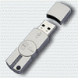

1. Each station is provided with its own USB key.

## Generic software licenses

Third party software licenses for operating systems, replay encode/decode and remote access operate without any physical key.

# Safety notes and instructions

The following instructions must be followed to ensure correct operation of the Sentinel System.

## Virus protection

The Sentinel system is a private data network. The user must observe the following precautions:

1. Never connect any part of the Sentinel system directly to the Internet or to an email or texting service of any kind unless a comprehensive external anti-malware anti-phishing and anti-virus is fully operational.
2. Never load any software or data files from a USB memory stick or portable hard drive.

## After using Audio Monitor

After listening to the live recording from any audio channel on any recorder, always ensure the service is closed before leaving the recorder. This is important because it ensures the network traffic loads are minimized, as high loads may impair the system performance.

## After using Live view

After viewing the live recording from any channel on any recorder, always ensure the service is closed before leaving the recorder. This is important because it ensures the network traffic loads are minimized, as high loads may impair the system performance.

Please note: Every time a live view is started, it forces the generation of a complete I-frame, which temporarily increases the network load.

## After RMV and IDX decoding

After decoding RMV or IDX files, an additional folder containing the export data, is located in the same folder location as the original data. It is recommended that these additional folders are either deleted or removed from the archives in order not to consume storage capacity.

Please note, these additional files automatically overwritten at the end of the archive period.

## After remote controlling any station

After taking control of any remote station, always ensure that all open windows are closed before returning to the Technical Supervisor. This is important because it ensures the network traffic loads are minimized, as high loads may impair the system performance.

## Scheduled maintenance

In order to reduce the number of warnings and alerts, it is recommended that maintenance of the system is always scheduled using the tools described below.

# User Interface

## Starting Technical Supervisor

Start the Technical Supervisor from the desktop icon as shown below:



1. Start up of the TECHNICAL SUPERVISOR.

The Technical Supervisor starts up in dedicated window, and may be used full or part screen. TSP will continue running until stopped.

The Technical Supervisor display shows the active stations list, which indicates the current status of each station, and enables the user to view current status messages.

## Active stations list

The active stations list provides a visual indication for all data channels and components in the system, using a mimic display of the installation.

The system is designed to operate unattended, and will generally return to normal operation after conditions that give rise to error states have been cleared. For example, the system will continue to record throughout the re-start cycle of a clients CWP.

Each node of the active stations list is colour coded as follows:

| **Default Colour** | **Meaning** | **Recommended action** |
| --- | --- | --- |
| **Green** | Operational | None |
| **Amber** | Operational, with warnings update | Review warnings, schedule maintenance if required. |
| **Red** | Operational, with error conditions | Review errors, schedule maintenance. |
| **Grey** | Offline | Start up system and maintenance mode |

## Changing the default node colours

|  |  |
| --- | --- |
| Place the mouse over the THRUPUT or Customer icons on the TSP display and single left click to display the drop down menu. | Logo drop down menu 1.png   1. Logo drop down menu |
| Select the General tab and amend the colour values as required.  These will be implemented when OK is pressed (single left click) | Logo drop down menu 2.png   1. Manage TSP menu |

## Mimic display

A typical mimic display is shown below:



1. Mimic display (inactive)

By performing a left click on any node, its current message report is revealed as shown below:

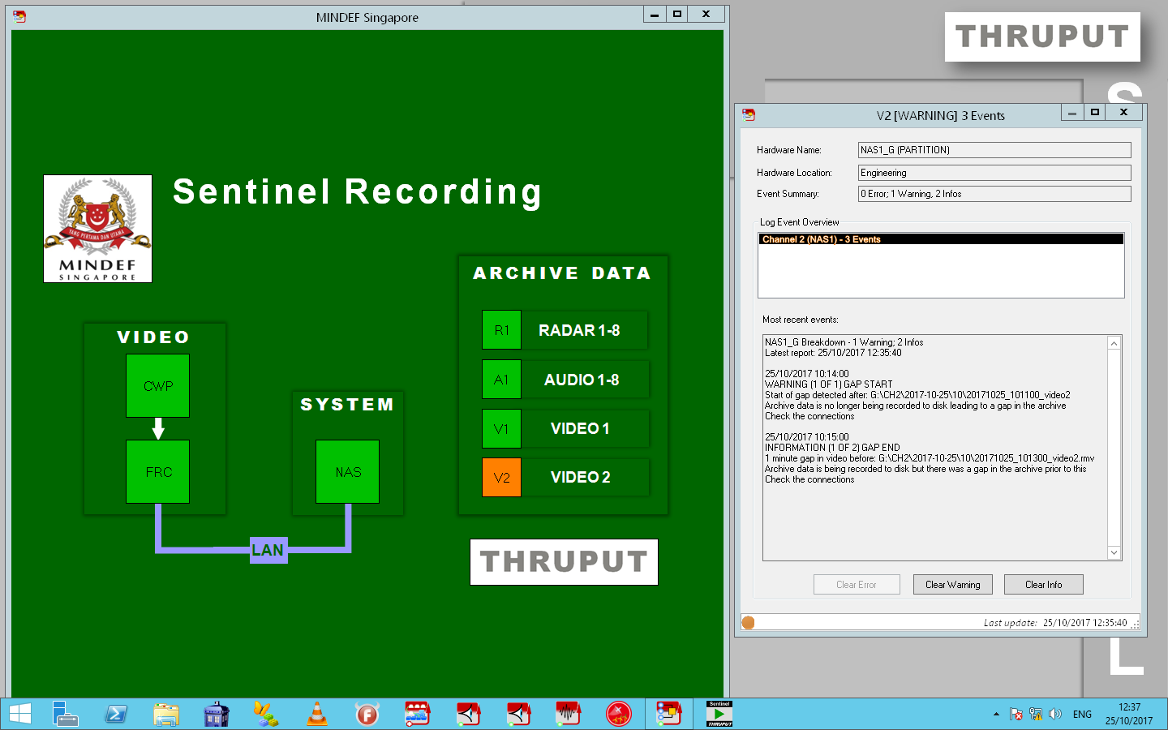

1. Message report

### Acknowledge messages

The controls provided to acknowledge messages are as follows:

|  |  |
| --- | --- |
| Alarm | Mutes the audio alarm for the currently detected error message. The audio alarm will be re-instated when a new error message is received. |
| Information | 1. Acknowledges all information messages. 2. Re-sets the TSP icon colour. 3. Hides previous information messages from the event viewer list. Note the event viewer can reveal all messages by selecting the show acknowledged control. |
| Warning | 1. Acknowledges all Warning messages. 2. Re-sets the TSP icon colour. 3. Hides previous Warning messages from the event viewer list. Note the event viewer can reveal all messages by selecting the show acknowledged control. |
| Error | 1. Acknowledges all Error messages. 2. Re-sets the TSP icon colour. 3. Hides previous Error messages from the event viewer list. Note the event viewer can reveal all messages by selecting the show acknowledged control. |

## List of messages

The list of messages available in the system is presented below, organised in order of severity into Information, warning and error messages.

Within each message class, the Short names (which is revealed when hovering over an icon) are arranged in alphabetical order.

### Information messages

| **Severity** | **Short\_Name** | **Reporter** | **Event Source** | **Description** | **Action** |
| --- | --- | --- | --- | --- | --- |
| INFO | ALARM\_ACTIVE | AlarmMan | AlarmMan | Alarm is still active | Check event log |
| INFO | ALARM\_CLEARED | AlarmMan | AlarmMan | Alarm has been cleared | None |
| INFO | ALARM\_SET | AlarmMan | AlarmMan | Alarm has been activated | Check event log |
| INFO | CHECKED | DiskMan | DRIVE | The partition has passed all tests. | None |
| INFO | COL\_EVENT | RecMan | SOURCE | Source video colour event detected | None |
| INFO | COL\_EVENT\_1 | RecMan | SOURCE | Colour Event #1 detected | None |
| INFO | COL\_EVENT\_10 | RecMan | SOURCE | Colour Event #10 detected | None |
| INFO | COL\_EVENT\_11 | RecMan | SOURCE | Colour Event #11 detected | None |
| INFO | COL\_EVENT\_12 | RecMan | SOURCE | Colour Event #12 detected | None |
| INFO | COL\_EVENT\_13 | RecMan | SOURCE | Colour Event #13 detected | None |
| INFO | COL\_EVENT\_14 | RecMan | SOURCE | Colour Event #14 detected | None |
| INFO | COL\_EVENT\_15 | RecMan | SOURCE | Colour Event #15 detected | None |
| INFO | COL\_EVENT\_16 | RecMan | SOURCE | Colour Event #16 detected | None |
| INFO | COL\_EVENT\_2 | RecMan | SOURCE | Colour Event #2 detected | None |
| INFO | COL\_EVENT\_3 | RecMan | SOURCE | Colour Event #3 detected | None |
| INFO | COL\_EVENT\_4 | RecMan | SOURCE | Colour Event #4 detected | None |
| INFO | COL\_EVENT\_5 | RecMan | SOURCE | Colour Event #5 detected | None |
| INFO | COL\_EVENT\_6 | RecMan | SOURCE | Colour Event #6 detected | None |
| INFO | COL\_EVENT\_7 | RecMan | SOURCE | Colour Event #7 detected | None |
| INFO | COL\_EVENT\_8 | RecMan | SOURCE | Colour Event #8 detected | None |
| INFO | COL\_EVENT\_9 | RecMan | SOURCE | Colour Event #9 detected | None |
| INFO | COMPRESSED\_FOLDER | ArchiveMan | DRIVE | ArchiveMan has compressed a folder | None |
| INFO | CONFIG\_UPDATE | ConfigMon | ConfigMon | Configuration has been automatically updated and/or copied to a remote system | None |
| INFO | DELETED\_FOLDER | DiskMan | DRIVE | DiskMan service successfully deleted folder | None |
| INFO | DISK\_IO\_RECOVERED | RecMan | RecMan | The DiskWrite service has resumed normal operation after a hard disk IO timeout. Data has been lost | Check disk capacity / operation |
| INFO | DISK\_NORMAL | RecMan | DRIVE | DiskWrite service is operating normally | None |
| INFO | DISK\_STARTED | RecMan | RecMan | DiskWrite service has started | None |
| INFO | DISK\_STOPPED | RecMan | RecMan | DiskWrite service has stopped | None |
| INFO | GAP\_END | RecMan | DRIVE | End of gap in video data | None |
| INFO | I\_FRAME | RecMan | SOURCE | Recorder has detected a complete I-Frame. | None |
| INFO | LOG\_STOP | RecMan | DRIVE | Monitoring stopped for application | None |
| INFO | NET\_STARTED | RecMan | RecMan | NetCapture service has started | None |
| INFO | NET\_STOPPED | RecMan | RecMan | NetCapture service has stopped | None |
| INFO | NTP\_ADJUST | NTP | NTP | NTP Daemon has made a minor adjustment to the system clock | None |
| INFO | NTP\_CONNECTION | NTP | NTP | NTP server connection established | None |
| INFO | NTP\_DRIFT | NTP | NTP | Minor difference noted between system clock and reported NTP time | None |
| INFO | REC\_START | RecMan | DRIVE | Recorder is running | None |
| INFO | SERVER\_CONNECTED | ServerMon | ServerMon | ServerMon has established a PING connection | None |
| INFO | SKIPPING\_FOLDER | ArchiveMan | DRIVE | ArchiveMan had no changes to make to the folder | None |
| INFO | SNMP\_HDD\_INSERTED | SnmpMon | SnmpMon | An HDD has been added to the system | Check RAID set |
| INFO | SNMP\_NTP\_UNKNOWN | SnmpMon | SnmpMon | SnmpMon received an unknown message from NTP | Check configuration |
| INFO | SNMP\_RAID\_LOGIN | SnmpMon | SnmpMon | User has logged into RAID controller | None |
| INFO | SNMP\_RAID\_TEST | SnmpMon | SnmpMon | SnmpMon received a test message from RAID | None |
| INFO | SNMP\_RAID\_UNKNOWN | SnmpMon | SnmpMon | SnmpMon received an unknown message from RAID | Check configuration |
| INFO | SNMP\_REBUILD\_COMPLETE | SnmpMon | SnmpMon | RAID has completed rebuilding a HDD | None |
| INFO | SOURCE\_OK | RecMan | SOURCE | Recorder is operating normally | None |
| INFO | SOURCE\_OK\_TRANS | RecMan | SOURCE | Recorder is operating normally | None |
| INFO | STARTED | AlarmMan | AlarmMan | AlarmMan service has started | None |
| INFO | STARTED | ArchiveMan | ArchiveMan | ArchiveMan has started | None |
| INFO | STARTED | ConfigMon | ConfigMon | Config Monitor has started | None |
| INFO | STARTED | DiskMan | DiskMan | DiskMan service has started | None |
| INFO | STARTED | LogClient | LogClient | LogClient started | None |
| INFO | STARTED | LogMon | LogMon | Logger service has started | None |
| INFO | STARTED | LogMon | LogMon | Log Monitor has started | None |
| INFO | STARTED | NTP | NTP | NTP Daemon has started | None |
| INFO | STARTED | RecMan | RecMan | RecMan service has started | None |
| INFO | STARTED | ServerMon | ServerMon | ServerMon has started | None |
| INFO | STARTED | SnmpMon | SnmpMon | SnmpMon stopped | None |
| INFO | STARTED | Watchdog | Watchdog | Watchdog Service has started | None |
| INFO | STOPPED | AlarmMan | AlarmMan | AlarmMan service has stopped | None |
| INFO | STOPPED | ArchiveMan | ArchiveMan | ArchiveMan has finished | None |
| INFO | STOPPED | ConfigMon | ConfigMon | Config Monitor has stopped | None |
| INFO | STOPPED | DiskMan | DiskMan | DiskMan service has stopped | None |
| INFO | STOPPED | LogClient | LogClient | LogClient stopped | None |
| INFO | STOPPED | LogMon | LogMon | Logger service has stopped | None |
| INFO | STOPPED | LogMon | LogMon | Log Monitor has stopped | None |
| INFO | STOPPED | NTP | NTP | NTP Daemon has stopped | None |
| INFO | STOPPED | RecMan | RecMan | RecMan service has stopped | None |
| INFO | STOPPED | ServerMon | ServerMon | ServerMon has stopped | None |
| INFO | STOPPED | SnmpMon | SnmpMon | SnmpMon started | None |
| INFO | STOPPED | Watchdog | Watchdog | Watchdog Service has stopped | None |
| INFO | UNCOMPRESSED\_FOLDER | ArchiveMan | DRIVE | ArchiveMan has uncompressed a folder | None |
| INFO | WATCHDOG\_NORMAL | AlarmMan | AlarmMan | AlarmMan detected Watchdog service | None |

### Warning messages

| **Severity** | **Short\_Name** | **Reporter** | **Event Source** | **Description** | **Action** |
| --- | --- | --- | --- | --- | --- |
| WARN | WATCHDOG | AlarmMan | AlarmMan | AlarmMan service has had a watchdog failure | Software will automatically restart |
| WARN | WATCHDOG\_TIMEOUT | AlarmMan | AlarmMan | AlarmMan did not detect Watchdog service | Check Watchdog status |
| WARN | FILE\_ERROR | ArchiveMan | DRIVE | ArchiveMan has failed to process a file | Data on disk is no affected |
| WARN | WATCHDOG | DiskMan | DiskMan | DiskMan service has had a watchdog failure | Software will automatically restart |
| WARN | WATCHDOG | LogMon | LogMon | Logger service has had a watchdog failure | Software will automatically restart |
| WARN | NTP\_LARGE\_ADJUST | NTP | NTP | NTP Daemon has made a large adjustment to the system clock | Check NTP source as this may indicate a failure within the system |
| WARN | NTP\_LARGE\_DRIFT | NTP | NTP | Large difference between system clock and reported NTP time | System will automatically adjust system clock when delay timer expires |
| WARN | DISK\_BUFFER\_RECOVERY | RecMan | RecMan | DiskWrite service is swapping buffer to disk to avoid data loss | Software will automatically recover |
| WARN | DISK\_WATCHDOG | RecMan | RecMan | DiskWrite service has had a watchdog failure | Software will automatically restart |
| WARN | DROPPED\_FRAME | RecMan | RecMan | DiskWrite service has dropped one or more video frames | Software will automatically recover |
| WARN | GAP\_IN\_PROGRESS | RecMan | DRIVE | Gap in progress in video data |  |
| WARN | GAP\_START | RecMan | DRIVE | Start of gap in video data | Manually copy data from backup recorder |
| WARN | LOG\_LATE\_START | RecMan | DRIVE | Application was detected before it was registration | None |
| WARN | LOW\_COMPRESSION | RecMan | SOURCE | Source video min compression rate exceeded | Check video source |
| WARN | RES\_CHANGE | RecMan | SOURCE | Source video has changed resolution | Check video source |
| WARN | RES\_CHANGE\_OK | RecMan | SOURCE | Record resolution matches detected resolution | None |
| WARN | WATCHDOG | RecMan | RecMan | RecMan service has had a watchdog failure | Software will automatically restart |
| WARN | SNMP\_RAID\_REBUILDING | SnmpMon | SnmpMon | RAID set rebuilding has begun | Wait for RAID set to rebuild. |
| WARN | SNMP\_REBUILD\_RAIDSET | SnmpMon | SnmpMon | RAID set needs rebuilding | None |
| WARN | SNMP\_UNKNOWN | SnmpMon | SnmpMon | SnmpMon has received an unknown event | Update configuration |
| WARN | WATCHDOG | Watchdog | Watchdog | Watchdog Service has detected a service timeout | Software will automatically restart |

### Error messages

| **Severity** | **Short\_Name** | **Reporter** | **Event Source** | **Description** | **Action** |
| --- | --- | --- | --- | --- | --- |
| ERR | MISSING\_FOLDER | ArchiveMan | DRIVE | ArchiveMan did not find any data within the folder. | Check configuration settings |
| ERR | BAD\_IO | ConfigMon | ConfigMon | IO Error accessing database file or folder | Check permissions on file and/or folder |
| ERR | BAD\_CONFIG | DiskMan | DiskMan | Error reading config | Check config |
| ERR | DELETE\_FAILED | DiskMan | DRIVE | DiskMan service was unable to delete folder | Check disk access. When fixed, software will automatically recover |
| ERR | EXCEEDING\_THRESHOLD | DiskMan | DRIVE | Disk free threshold exceeded and nothing to delete | Manually free disk space by archiving old files |
| ERR | MISSING\_FOLDER | DiskMan | DRIVE | DiskMan could not find a folder to maintain | Manually check configuration |
| ERR | LOG\_FAILED | LogClient | LogClient | LogClient has failed to complete action | Check for latest software updates |
| ERR | SMTP\_TIMEOUT | LogMon | LogMon | Unable to access SMTP server | Check SMTP access |
| ERR | BAD\_CONFIG | NTP | NTP | NTP Daemon has an invalid setting | Check configuration |
| ERR | NTP\_TIMEOUT | NTP | NTP | NTP Daemon timed out trying to contact server | Check NTP server and LAN connectivity |
| ERR | DISK\_BUFFER\_OVERFLOW | RecMan | RecMan | Record buffer error detected | Software will automatically restart |
| ERR | DISK\_FRC\_WATCHDOG | RecMan | FRC | Sentinel Recorder has had a watchdog failure | Check Sentinel Recorder and network connections |
| ERR | DISK\_IO\_FAILURE | RecMan | RecMan | DiskWrite service was unable to write video to disk | Check disk access |
| ERR | NET\_WATCHDOG | RecMan | RecMan | NetCapture service has had a watchdog failure | Software will automatically restart |
| ERR | NO\_SOURCE | RecMan | SOURCE | Source video not detected | Check video source |
| ERR | NO\_SOURCE\_TRANS | RecMan | SOURCE | FRC is reporting 1 or more frames has no source. (Diagnostics) | Check video source |
| ERR | REC\_WATCHDOG | RecMan | DRIVE | Recorder watchdog has expired | Software will automatically restart |
| ERR | UNKNOWN\_CHANNEL | RecMan | RecMan | Channel not registered in config | Check config |
| ERR | UNKNOWN\_EVENT | RecMan | RecMan | Received unknown event ID on network | Check config |
| ERR | UNKNOWN\_STATE | RecMan | RecMan | Received unknown state on network | Check NetCapture version |
| ERR | SERVER\_TIMEOUT | ServerMon | ServerMon | ServerMon was unable to PING connection | Check network connectivity |
| ERR | SNMP\_HDD\_REMOVED | SnmpMon | SnmpMon | A HDD has been removed from the system | Check RAID set |
| ERR | SNMP\_LAN\_DISCONNECT | SnmpMon | SnmpMon | SnmpMon has detected NTP has stopped | Software will automatically restart |
| ERR | SNMP\_RAID\_DEVICE\_FAILED | SnmpMon | SnmpMon | An HDD has failed | Replace HDD at earliest opportunity |
| ERR | SNMP\_RAID\_VOLUME\_DEGRADED | SnmpMon | SnmpMon | Volume within RAID set has degraded | Rebuilding has started |
| ERR | SNMP\_RAID\_VOLUME\_FAILED | SnmpMon | SnmpMon | Volume within RAID set has failed | Replace faulty hardware, and rebuild raid set |
| ERR | SNMP\_RAIDSET\_DEGRADED | SnmpMon | SnmpMon | RAID set has been degraded because one or more drives have failed | Replace HDD at earliest opportunity |

## Taking control of a station

The Technical Supervisor is able to take control of any archive hardware via remote access, using the following procedure:

1. Place the mouse over the station of interest and perform a left mouse click.
2. The system will open a link to the desktop of the selected NAS. TSP mouse and keyboard are now in control of the NAS.

When in control of a station, the user is able to perform the flowing duties:

* Live view any channels of data.
* Inspect the performance of the Sentinel recorders directly from the archive using the IDX decoder tool.
* Inspect stored file sizes and create stills or movies directly from the archive using the RMV decoder tool.
* Update Sentinel video recorders with new Setting up instructions such as:
* Frame rate.
* The ratio of {RLE (I line)} to {RLE + differences (P line)}.
* Noise filter settings Pixel to pixel (I) and frame to frame (P)colour filtering.
* Track host system resolution changes.
* Trap colour events such as: STCA, alerts, and provide event statistics.
* IP and port addressing.
* Start and stop any processes.

### To close a remote viewing window

To close a remote viewing window, move the mouse over the CLOSE button, and single left click.

### Maintenance mode

Maintenance mode enables the user to isolate affected channels recorder from the Technical Supervisor. In this case, messages from the affected channels are suspended until the maintenance period ends.

To enter maintenance mode, place the mouse over the THRUPUT or Customer icons on the TSP display and single left click to display the drop down menu:

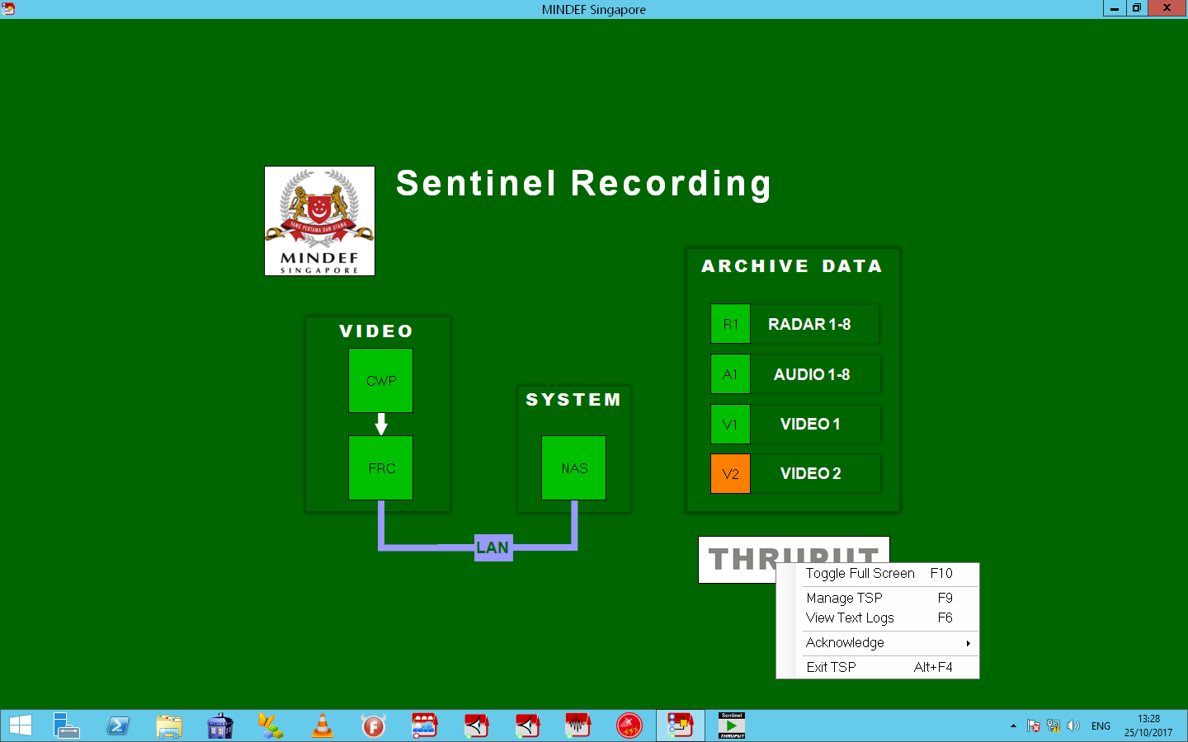

1. Logo drop down menu

Left click on the Manage TSP and then select the Maintenance tab:

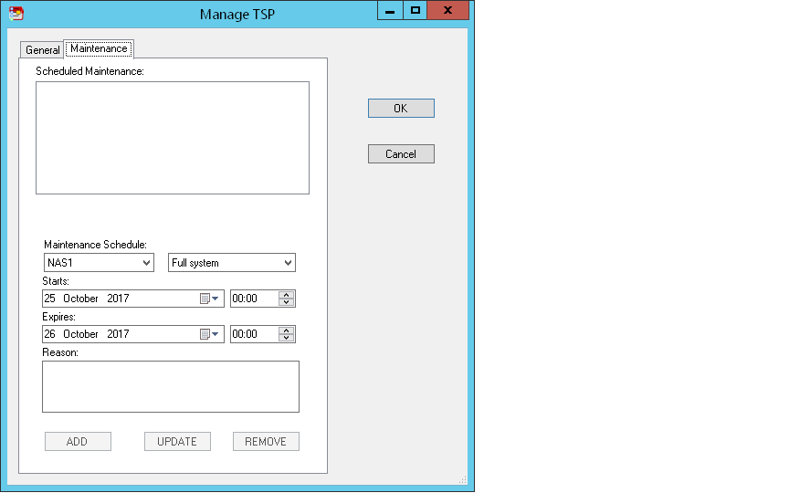

1. Maintenance tab

Complete the required fields as needed and select OK.

|  |  |
| --- | --- |
|  |  |
|  |  |
|  |  |
|  |  |
|  |  |